Intro to Rocks Guide
A rock is a mixture of minerals. (example: granite is made of 3-4 minerals)
Geologists (scientists who study rocks) classify rocks according to three things:
- MINERAL TEXTURE:
  - Size of grains
- Coarse-grained (can be seen without a microscope)
- Fine-grained (microscopic)
- No grains—glassy because no crystals formed
  - Shape of grains—smooth or jagged
  - Pattern of grains—wavy; flat
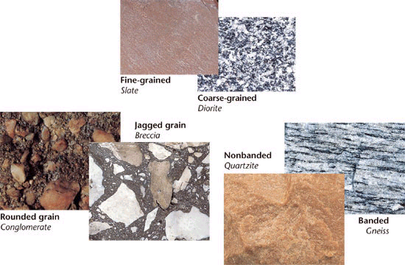

2. MINERAL COMPOSITION (what the rock is made of)
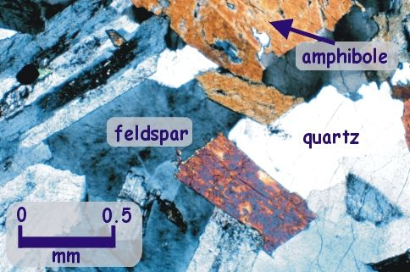

3. ORIGIN of rock (where did the rock FORM?):
- Igneous Rock:
>How do they form?
Melted/molten rock (lava or magma) cools and hardens

>examples:
Basalt, granite, obsidian

- Sedimentary Rock: (most of the rocks on Earth are sedimentary)
>How do they form?
pressure (usually underwater)

>List 3 examples of sediment:
Pieces of rock, sand, mud, bones, shells

>examples of sedimentary rock:
Shale, limestone, sandstone

(Some sedimentary rock have fossils from extinct animals/plants---paleontology)

- Metamorphic:
>How do they form?
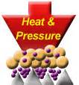
extreme heat and pressure (usually very deep underground)

>examples: marble, gneiss

