Earth’s Resources study notes:
What is a NATURAL RESOURCE?
- something humans use that we get from nature (not artificial)
What is a renewable natural resource?
- a natural resource that can grow back (or can be remade/replenished) in less than 100 years
Give examples of renewable natural resources:
- trees, wood, paper
- Solar energy
- Wildlife (fish, etc)
- Water
- Wind energy
- Geothermal energy
What is a nonrenewable natural resource?
- a natural resource that cannot be replaced if used up (or it would take thousands or millions of years)
Give examples of nonrenewable natural resources:
- rocks and minerals
- Oil/petroleum
- Coal
- Nuclear energy
What are the 3 types of fossils fuels (all NONrenewable resources)?
- __coal______ =solid
- __oil/petroleum =liquid
- __natural gas (like methane) =gas
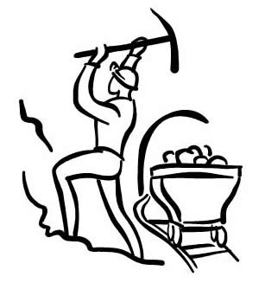
How do we get rocks and minerals from the Earth?
- mining (digging in the earth

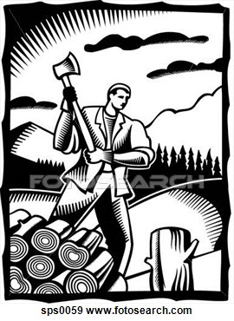
What are some negatives of mining?
- expensive
- Dangerous
- Bad for environment
- (ex: deforestation)

>so reduce, reuse, recycle!!!

What are the main differences between minerals and rocks?

Minerals Rocks
- elements or 1. MIXTURES of
compounds minerals
- not organic 2. some rocks
(not made of are organic
things that are material (ex:
or were once limestone has
living) shells in it)

